Lab 2: Strain Gauge Load Cell Report

TRC3500 Sensors and Artificial Perception

## Lab members

|  |  |
| --- | --- |
| Kun Zhang | 22701478 |
| Seow Sheng Lun | 22724281 |

**1. Introduction**

Strain gauge is a device used to measure strain of an object, where changes in electrical resistance occur when an object is stretched. In this lab, a strain gauge was mounted at the end of a steel strip (metal ruler) and clamped at the edge of a table. Then, a 0.1kg weight was placed at certain lengths of the ruler, which caused the ruler to deflect and changed the resistance on the strain gauge. The change in resistance was later measured after it went through signal amplification and filtering process.

**2. Equipment and Components**

Equipment used in this lab:

* Oscilloscope
* Multimeter
* Hook-up wires
* Prototyping plug board

Components used in the circuitry design:

* LM324 quad operational amplifier
* Steel strip with attached strain gauge
* 0.1kg weight
* G-clamp
* Resistors (Ω): 100, 120, 560k
* 1kΩ Potentiometer

**3. Procedures**

1. The steel strip with attached strain gauge was clamped at the edge of the table using the G-clamp provided.
2. Initial measurements were made to calculate the maximum stress and strain that the gauge will experience and also to work out the necessary components values for the circuitry design part.
3. The strain gauge was later connected to the circuitry for some initial testing. Details of the circuitry are elaborated in ‘Circuit’ section.
4. A 0.1kg weight was placed 1cm away from the tip of the rule.
5. The deflection of the rule and output from the circuit were measured and recorded.
6. Step 4-5 were repeated with weight placed at different distance ---- 5cm, 50cm, 100cm, 120cm and 150cm.
7. Further calculations were made using the obtained results and to be discussed further in ‘Calculation’ and ‘Discussion’ sections.

# 4. Theoretical Background

From physics we know that Young’s Modulus, E of a cantilever beam (Figure 1) can be obtained by

$$E=\frac{Fl^{3}}{3δI}$$

where

$$δ=deflection of the cantilever beam$$

$$I=the scond moment of the beam$$

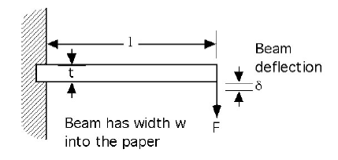

Figure 1: Cantilever beam

The second moment of cross-section of a rectangular beam, I is

$$I=\frac{wt^{3}}{12}$$

where w is the width of the beam I and t is the height.

The maximum surface stress, $σ$ is

$$σ=\frac{3δEt}{2l^{2}}$$

And the strain can be calculated by

$$ε=\frac{σ}{E}$$

For a Wheatstone bridge configuration, if one of the elements is gauge and all the other elements are resistors of the same nominal value, then the voltage across the gauge is related to its resistance by

$$ΔV_{output}=\frac{V_{supply}ΔR}{2R (2+ΔR/R)}$$

$$ΔV_{output}=\frac{V_{supply}r}{2*(2+r)}$$

where

$$\frac{ΔR}{R}=r$$

Therefore, we can obtained the gauge factor by

$$K=\frac{r}{ε}$$

**5. Circuit**

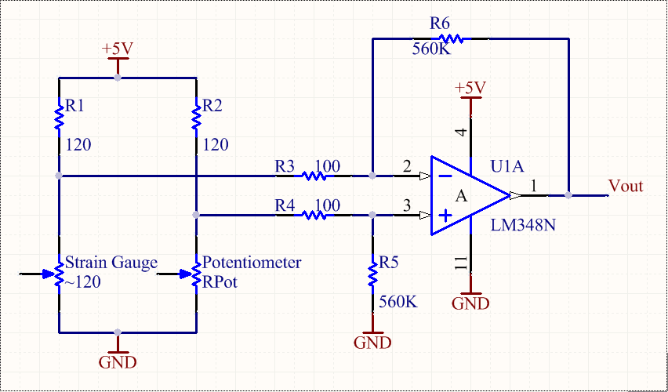

Figure 2: Schematic diagram of the complete circuit

In order to measure the changes in resistance from the strain gauge, a Wheatstone bridge circuit was constructed to produce an output voltage differences. Strain gauge’s resistance value was found to be around 120Ω. Therefore, the first arm of the Wheatstone bridge was consisted of a fixed resistor (120Ω) and a strain gauge (~120Ω), followed by a fixed resistor (120Ω) and a 1kΩ potentiometer to form the second arm.

When there is no strain on the strain gauge, the output voltage differences from the Wheatstone bridge should be about 0V. In real world situation, it is hard to obtain 0V output voltage differences and that’s why a potentiometer was used on one of the arm, to tune the Wheatstone bridge to obtain the output voltage differences as close as 0V during idle period. When force is applied on the rule, it causes a change in gauge resistance and thus giving out an output voltage differences from the bridge.

Due to a very small changed in gauge resistance, output voltage from the bridge did not give a very significant output. To overcome this problem, the output from the Wheatstone bridge was connected to a differential amplifier, which constructed using LM324 quad operational amplifier chip, two 100Ω resistors to the inputs, one 560kΩ resistor from non-inverting input to ground and finally a negative feedback of another 560kΩ resistor for a stable gain of around 5600.   
With a complete circuit as shown in Figure 2, the change in gauge resistance can be observed clearly. Hence, we could proceed with our testing to measure all the necessary output voltages using the 0.1kg weight placed at different distance to determine the characteristic of our strain gauge.

# 6. Results

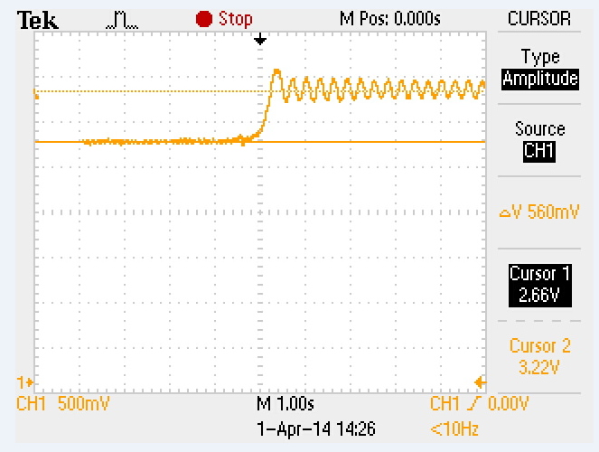

Figure 3: Voltage output from the circuit

With no weight hung on the rule, the voltage across the gauge stabilized at 2.66 V. After hanging the weight of 0.1 kg at the tip of the rule, the voltage reading increased to 3.22. The voltage difference was 560 mV as shown in Figure 3.

By hanging the weight at different locations on the rule, we obtained the records as follows

|  |  |  |  |  |
| --- | --- | --- | --- | --- |
| **Distance (cm)** | **Voltage (mV)** | **Initial Voltage (mV)** | **Voltage Dff. (mV)** | **Deflection (mm)** |
| 1 | 3220 | 2660 | 560 | 0.02 |
| 5 | 2800 | 2270 | 530 | 0.0185 |
| 50 | 2810 | 2300 | 510 | 0.0181 |
| 100 | 2820 | 2320 | 500 | 0.0178 |
| 120 | 3070 | 2580 | 490 | 0.0175 |
| 150 | 3110 | 2630 | 480 | 0.0173 |

Figure 4 Record for weight at different locations

Plotting voltage difference versus deflection, we have

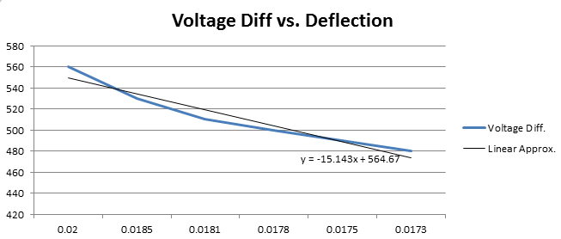

Figure 5: Voltage difference versus deflection

We can observe that the relationship between voltage difference and deflection is linear. This is in accord with theory in which voltage difference is inversely proportional to deflection.

# 7. Calculation

Measured data was used for calculations. The data are shown below

|  |  |  |  |  |
| --- | --- | --- | --- | --- |
| **Distance (cm)** | **Voltage (mV)** | **Initial Voltage (mV)** | **Voltage Dff. (mV)** | **Deflection (mm)** |
| 1 | 3220 | 2660 | 560 | 0.02 |

The second moment of cross-section of a rectangular beam I is

$$I=\frac{wt^{3}}{12}=\frac{0.025×{0.001}^{3}}{12}=2.083×{10}^{-12} m^{4}$$

The applied force F is obtained by knowing the mass of the weight being 0.1 kg

$$F=mg=0.1×9.81=0.981 N$$

The deflection is measured as

$$δ=0.02 m$$

Its Young’s modulus is calculated as

$$E=\frac{Fl^{3}}{3δI}=\frac{0.981 ×{0.255}^{3}}{3×0.02×2.083×{10}^{-12}}=1.30×{10}^{11} N/m^{2}$$

So, the maximum surface stress $σ$ is evaluated as

$$σ=\frac{3δEt}{2l^{2}}=\frac{3×0.02×1.30×{10}^{11}×2.083×{10}^{-12}}{2×{0.255}^{2}}=6.00×{10}^{7}N/m^{2}$$

And the strain can be calculated by

$$ε=\frac{σ}{E}=\frac{6.00×{10}^{7}}{1.30×{10}^{11}}=4.61×{10}^{-4}$$

The voltage difference is 560 mV with an amplification gain of 560, hence the ratio of resistance change r is

$$ΔV_{output}=\frac{V_{supply}r}{2*(2+r)}$$

$$\frac{0.56}{560}=\frac{5r}{2*(2+r)}$$

$$r=8.00×{10}^{-4}$$

Therefore, the gauge factor K is

$$K=\frac{r}{ε}=\frac{8.00×{10}^{-4}}{4.61×{10}^{-4}}=1.73$$

Similarly, we can calculate the gauge factor K using the data obtained when the weight is placed at other locations. The K values are

|  |  |  |  |  |  |  |
| --- | --- | --- | --- | --- | --- | --- |
| Location (mm) | 1 | 5 | 50 | 100 | 120 | 150 |
| Deflection (m) | 0.02 | 0.0185 | 0.0181 | 0.0178 | 0.0175 | 0.0173 |
| K factor | 1.734694 | 1.774842 | 1.745585 | 1.740188 | 1.734607 | 1.718839 |

The mean of K factor is 1.7415. Plotting gauge factor against deflection in MATLAB, we have

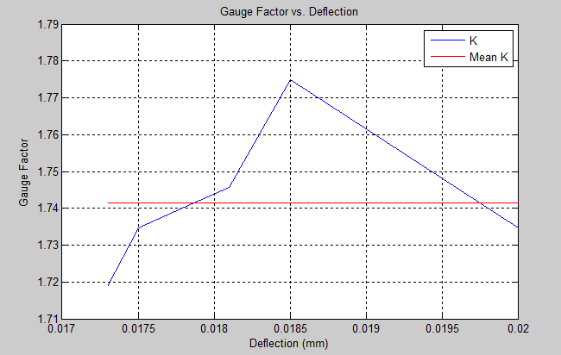

Figure 6: Gauge factor vs. deflection plot

# 9. Discussion

During the practice, one of the major problems we encountered was that the potentiometer was too sensitive. In other word, it was very difficult to adjust the knob of the potentiometer to a precise location where the output voltage of the Wheatstone bridge to be 0V. In practice, we managed to calibrate the potentiometer so that the output voltage (before amplification) was less than 5mV. However, it still gave us a large offset in the amplified outputs that the voltage readings were all greater than 2V as shown in Table 1. This puts a limit on the amplification gain, as a larger gain will render the output clipped from the supply voltage. However, a small gain would not be able to give a swing of 2V to our gauge. For our case, the swing was less than 2V.

A solution to this problem is to put a larger resistor in series with the potentiometer. In this way, the change of resistance in potentiometer will be less significant to the change of the output voltage of the Wheatstone bridge. In other words, a large change in the potentiometer will render a small change at the output, which eases the calibration process.

Another problem we had was the clipping of the amplifier. Initially, we used a large resistor values for the amplification stage and we found that no matter how much we change the deflection of the gauge, the output level was clipped at 4.2V. This was a typical clipping scenario as the supply voltage to the amplifier was set to +5V and the output would always clip at a voltage less than the supply voltage. As a result, we used resistors of lower values and then the outputs were able to vary according to the inputs.

In addition, self-heating of the strain gauge is an insidious problem. Most gauges are made of alloys. As current passes through the strain gauge, it dissipates heat which causes thermal expansion leading to the resistance of the strain gauge to vary to a small extent. This tiny change can be picked up, which messes up the final results. Therefore, to avoid a large current, we set the power supply of the amplifier to +5V which was the minimum voltage required for the amplifier. Also, the use of Wheatstone bridge made the circuit less susceptible to temperature changes as well as errors in voltage supply.

Strain gauge is a useful device that can be used in many applications. They can be used to measure vibration, torque, bending, deflection, compression and tension. Specifically, they are able to function as impact sensors, dental sensors, web sensors and they can measure force on hydraulic or pneumatic press, measure force in machine tools, etc.

**10. Conclusion**

In this lab prac, a strain gauge along with a signal processing circuit has been constructed and properly tested. The gauge factor of the strain gauge has been calculated from the data obtained by placing a weight at different position on a metal rule. The processing circuit consisted of an amplification stage which intensified the output of the Wheatstone bridge. The final output range was less than 2V, which could have been fixed if time permitted.